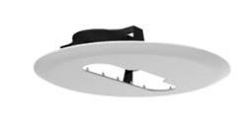
DS-1227ZJ-P1
Inceiling Mount

Feature
- Metal plate & plastic with surface spray treatment
- Easy installation method
Dimension
Available Model
DS-1227ZJ-P1
Parameter
Model  Parameters | DS-1227ZJ-P1
 | Inceiling Mount
Appearance | Hikvision White
Material | Metal Plate & Plastic
Dimension | Ø 253.4 mm × 38.4 mm (Ø 9.97" × 1.51")
Weight | 460 g (1.01 lb.)
Note
- The mount should be installed in the flat ceiling.
- he ceiling must be capable of supporting at least 3 times as much as the total weight of the camera, and the mount.
- The mount’s maximum load capacity is 1 kg (2.2 lb.).
0100001080615

